White Paper Briefs

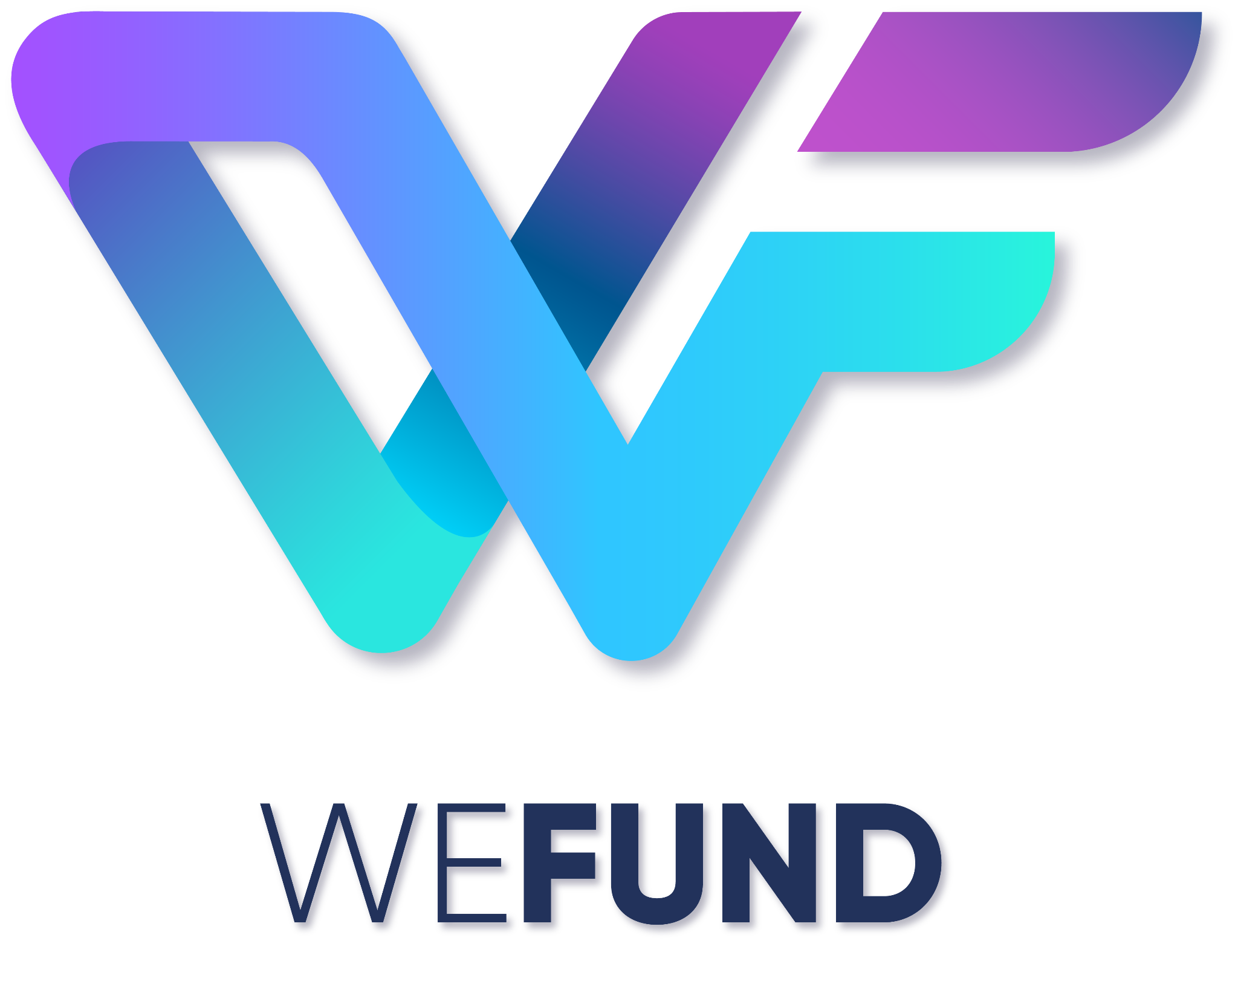

# TABLE OF CONTENTS

**TABLE OF CONTENT****S 2**

**EXECUTIVE SUMMARY** **4**

**Legal Disclaimer** **6**

**Risk Statement** **7**

**Introduction** **8**

**Why Start with TERRA?** **10**

**WEFUND: ONE GOAL, ONE PASSION.** **12**

**PLATFORM** **12**

Functionality of project proposers: 12

Functionality of the backers: 12

**Competitive Advantages** **14**

**Industries Inside WeFund’s Platform 2021-2022:** **15**

**Use Case Example** **15**

**Upcoming Industries:** **15**

Sport Example 15

Game Example 16

Real Estate example 16

Content Creators 16

**How the Project Works (Interface)** **17**

**Tokenomics** **19**

**Token Value** **21**

**Profit Sharing Distribution** **22**

**Token Vest Period** **23**

**Token Utility** **24**

**Anti-Scam Measurement:** **25**

**Technical Roadmap WeFund** **26**

**Partners Integration** **26**

**TEAM** **27**

Founders 27

Advisors 27

Other Team 28

**References** **29**

# EXECUTIVE SUMMARY

WeFund is a crowdfunding platform with the aim of creating a space for backers and creators in order to raise the necessary resources for the realization of the project via the means of backers communities. A cryptocurrency, or crypto, is a digital asset designed to work as a medium of exchange wherein individual token ownership records are stored in a shared ledger existing in a form of computerized database using strong cryptography to secure transaction records, to control the creation of additional token, and to verify the transfer of token ownership. This is called the blockchain. It typically does not exist in physical form and is typically not issued by a central authority. Cryptocurrencies typically use decentralized control as opposed to centralized digital currency and central banking systems.

WeFund is built on the innovative Terra Network, an open source, decentralized protocol for digital currency to fiat money transfers allowing cross-border transactions between any type of currency. Terra's protocol is supporting the infrastructure for this cryptocurrency. WeFund partners with Anchor, Mirror and Angel protocols as supporting protocols to ensure connectivity, yield staking, and sustainability in the means of charitable projects. WeFund aims for competitive advantages for its backer in its platforms such as yield benefit, governance voting power, secure and refundable deposit, promising low risk investment, NFTs mirror of real-world assets, and a system of deflationary token value.

WeFund can help users globally control their assets, access their funds anytime anywhere, safeguard their data with cryptography secure blockchain making data tempering highly unlikely, and protect their identity with a decentralized network. In our journey to achieve this vision, we are redefining how money is being moved, spent, and invested.

WeFund is utilizing blockchain technology to design beautiful, simple and useful financial services that have a lasting, positive impact on society, supporting all kinds of industries and projects such as crypto-based projects, real estate, gaming, sport, music, film, etc in all over the world.

The core of WeFund would be existing with the Terra ecosystem and, thanks to the strength of stablecoins, the use of Anchor Protocol and Mirror protocol we can offer a fundraising system guaranteeing the return on investment in the event that the project does not achieve its purpose.

# Legal Disclaimer

This whitepaper does not constitute investment advice, financial advice, trading advice, or recommendation by WeFund affiliates, or its respective or prospective officers, directors, managers, employees, agents, advisors, or consultants on the merits of purchasing WeFund nor should it be relied upon in connection with any other contract or purchasing decision. This whitepaper does not constitute a prospectus or financial service offering document and is not an offer to sell or solicitation of an offer to buy any security, investment products, regulated products or financial instruments in any jurisdiction. WeFunds and tokens are not being structured or sold as securities.

No representations or warranties have been made to the recipient of this whitepaper or its advisers as to the accuracy or completeness of the information, statements, opinions or matters (express or implied) arising out of, contained in or derived from this whitepaper or any omission from this document or of any other written or oral information or opinions provided now or in the future to any interested party or its advisers This whitepaper also does not constitute any form or any part of any opinion which can be considered an advice, or which can sell, or which can solicit any offer by WeFund to purchase our token nor shall it be considered a part of any effect which can be used for the formation of contract or investment decision. This whitepaper also does not have any capacity to bind any person to enter into any contract or consider it a binding legal commitment to the contribution of the whitepaper.

# Risk Statement

Purchasing crypto tokens involves substantial risk and may lead to a loss of a substantial or entire amount of the money involved. Prior to purchasing any crypto tokens, one should carefully assess and take into account the risks, including those listed in any other documentation. A purchaser should not purchase crypto tokens for speculative purposes. Purchasers should only purchase tokens if they fully understand the nature of these tokens.

The regulatory status of cryptographic tokens and digital assets is currently unsettled, varies among jurisdictions and is subject to significant uncertainty. It is possible that in the future, certain laws, regulations, policies or rules relating to cryptographic tokens, digital assets, blockchain technology, or blockchain applications may be implemented which may directly or indirectly affect or restrict cryptographic token holders’ right to acquire, own, hold, sell, convert, trade, or use cryptographic tokens.

The uncertainty in tax legislation relating to cryptographic tokens and digital assets may expose cryptographic token holders to tax consequences associated with the use or trading of cryptographic tokens. Digital assets and related products and services carry significant risks. Potential purchasers should take into account all of the above and assess the nature of, and their own appetite for, relevant risks independently and consult their advisers before making any decisions. You should consult a lawyer, accountant, tax professional and/or any other professional advisors as necessary prior to determining whether to purchase crypto tokens.

# Introduction

WeFund, formerly known as Fan$quad, is a decentralized crowdfunding platform for the creative industry and beyond. WeFund's initial idea was to provide a fundraising platform for the music and film industry, however, the founders recognized the opportunity to expand the platform’s reach to real estate, gaming, sports, and more. Therefore, WeFund had to rebrand to build a stronger business strategy and the potential to attract a larger market. Below is the market size of the top 5 industries which WeFund would like to adopt on the first platform launch.

Table 1.1 Industry and Market Size

| Industry | Market Size |
| --- | --- |
| Real Estate | $10.5 trillion market in 2020 |
| Gaming | $1.36 trillion market in 2020 |
| Sport | $1.1 trillion market in mid 2021 |
| Film | $244 billion market in 2021 |
| Music (concert and production) | $59 billion revenue in 2020 |
| Crypto | 6,000 projects in 2021 |

source: *msci.com, 2020; companiesmarketcap.com,2020; businesswire.com,2020; statista.com,2020; signa-sportunited.com,2020.*

The part that makes this project unique and almost limitless is that we will develop tokens on all blockchain ecosystems and these tokens will allow us to use the platform globally. This concept will grow all ecosystems (Terra, Ethereum, etc) and allow creators to make all projects “real”.

Based on the data, real estate has the biggest market compared to the other industries observed and gaming has a bigger market than the content creator industry. Therefore, WeFund saw greater potential and rebranded to make the strategy more effective than before. In addition, the industries mentioned above will be the main industries featured on the platform demo and app launch. WeFund is a crowdfunding platform, therefore, WeFund is able to feature various projects including NGO, NFT, crypto/blockchain, and more.

According to Best (2021), there are more than 6,000 crypto/blockchain projects as of 2021 - a considerable increase from a small handful of digital coins in 2013. Due to how open the creation process of a cryptocurrency is, it is relatively easy to make one. It is believed that the top 20 cryptocurrencies account for nearly 90 percent of the total market. Considering the rapid growth of the crypto projects and lenient policies, WeFund is focusing primarily on the crypto crowdfunding project industry to be utilized on the platform because of its ease of implementation compared to the other industries.

Since the founding of the project, it has attained considerable audience interaction.

Picture 1.1 The Summary Fansquad Analytic Account

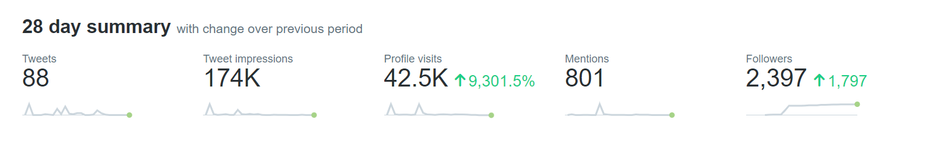

*source: fansquad twitter, 2021*

Based on the engagement analytics, the total impressions in September (28 days) was 174.000, with a total 2,397 followers.

Picture 1.2 The Engagement of Fansquad Twitter Account

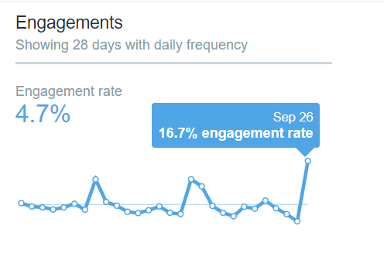

*Source: WeFund (Fansquad) twitter, 2021*

Based on the picture above, the average engagement rate was 4.7% with 16.7% being the highest engagement rate. According to Mee, G (2021) an engagement rate between 0.33% and 1% is considered to be very high, with expected reactions to be between 3.3 - 10 for every 1,000 Twitter followers. Meanwhile, the average engagement rate for WeFund (Fansquad) was 4.7%. This means the engagement rate of Fansquad is considered as excellent. Thus, the WeFund community supported the idea and the team saw the scalability of this project.

# Why Start with TERRA?

Apart from the fantastic community and open-minded approach of Terra Form Labs executives, the quality and originality of the farming techniques and synthetic assets with ultra-low gas fees are what distinguishes the Terra Ecosystem. Even under negative market situations, a stable 20% return on stablecoin deposits, Terra welcomes you!

Terra is the 4th largest blockchain in terms of total value locked (TVL), with over $7.55 billion dollars because of the unique applications and cheap gas prices of the Mirror, Anchor, Pylon Protocols along many other projects that have been released.

Picture 1.3 TVL Blockchain Overview

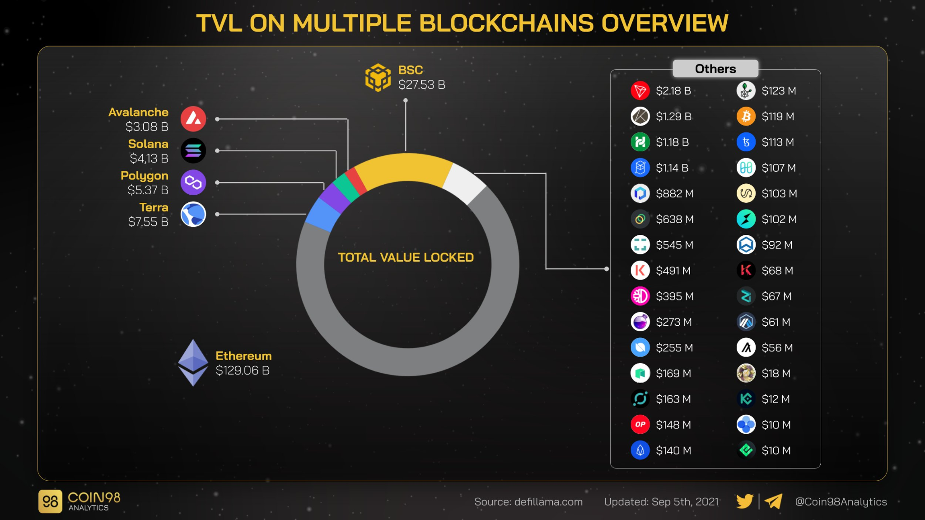

This led us to the obvious conclusion: As Terra is the TVL leader with only several live protocols, we can expect a substantial surge of funding in the queue. In addition, Terra also set aside $150 million dollars in their community fund that can be accessible to the developer community, therefore, it can be expected that there will be many projects that will be launched in the near future.

Picture 1.4 Terra Ecosystem

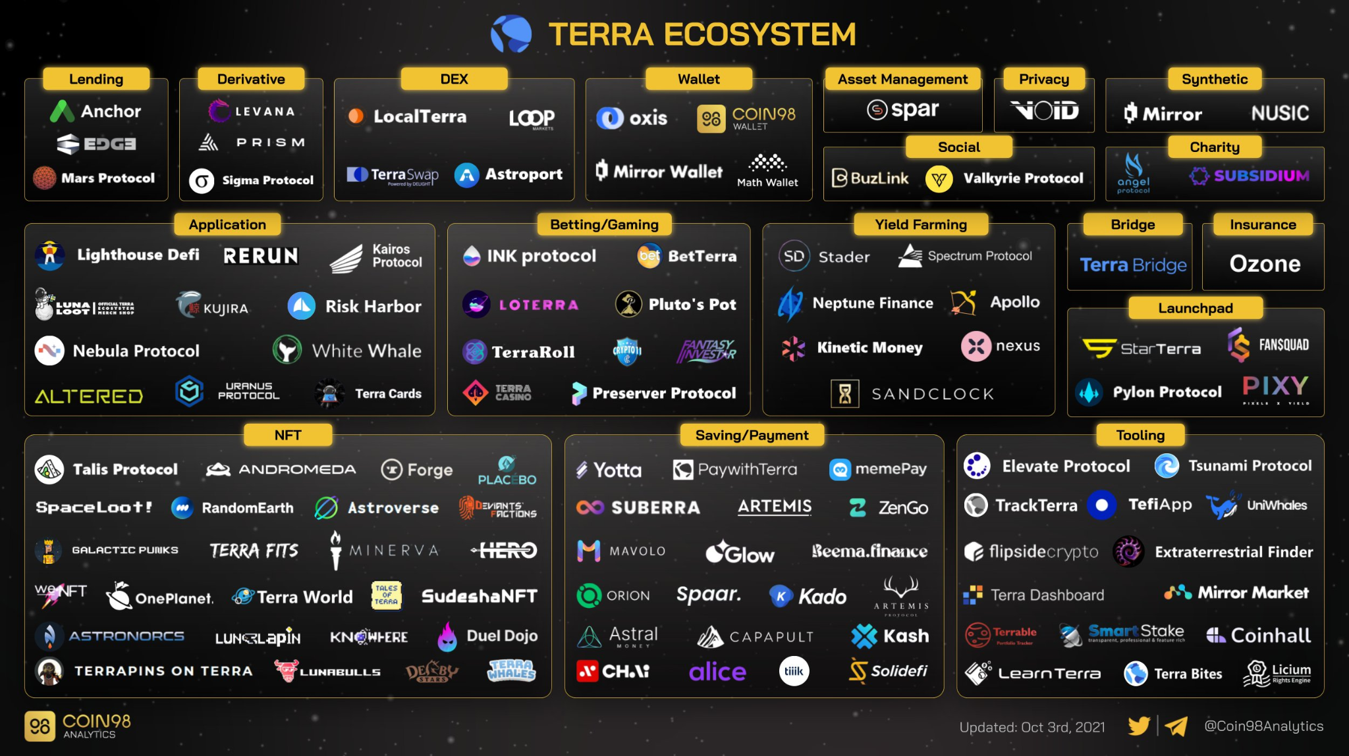

Finally, here is WeFund, formerly called Fan$quad, which has been recognized by the Terra community and decided to use Terra as our first starting ecosystem. Not to mention that WeFund uses the Terra ecosystem protocol to integrate protocols such as Mirror Protocol, Anchor Protocol, however, WeFund would like to integrate with NFTs protocol that exist on Terra Ecosystem for each industry that WeFund will include

# WEFUND: ONE GOAL, ONE PASSION.

The vision of WeFund is to become a connector of existing blockchain ecosystems and create real assets in real life the mirror protocol. In order to fulfil this vision, WeFund's initial development stage will be in the Terra ecosystem and will expand to other ecosystems such as Solana, Ethereum, Cardano, etc in the near future. WeFund, formerly known as Fan$quad, rebranded because the Co-Founders saw a better market opportunity. Fan$quad was created to develop a platform for artists or creators only, integrating with Anchor protocol to create 20% yield and then going to Pylon protocol allowing user to use the token. With this strategy, the user won't lose the money invested because even if there is a failed project, or if the project failed due to budget reasons, the user can either withdraw the fund or agree on a delay.

WeFund uses several protocols on the Terra ecosystem including Anchor, Pylon, and Mirror protocols. WeFund also integrates with the Angel protocol and several NFT projects as the WeFund project is NFT based.. Here is how it works:

# PLATFORM

## Functionality of Project Proposers:

The most difficult aspect of starting a business is obtaining funding. Here are the benefits of using WeFund:

* Anyone can propose cool project ideas or even fund tangible projects.
* Proposers can connect directly to investors (including WeFund), fans, backers, or venture capital.
* In order to increase visibility, proposers can create ad campaigns on WeFund to get premium ad placement.
* Proposers benefit from funding plus 10% generated from Anchor.
* The proposers have the option to offer profit sharing/token allocation, etc to project backers.

## Functionality of the Project Backers:

Financing a project is the biggest obstacle when starting a project. The WeFund platform offers several benefits to the backers of projects:

* Investors, Venture Capital, or WeFund can easily find amazing projects to be funded directly via the WeFund platform without needing to find unique projects the more traditional way.
* Backers, Fans, or Supporters can fund the project and receive 10% generated from Anchor Protocol and profit sharing (depending on the proposal of its project).
* There is no minimum or maximum budget to be invested in a project allowing anyone and everyone to be an investor.
* The WeFund platform will be the bridge between the real world and blockchain, meaning in the future, payment/funding can come through MasterCard, Visa, PayPal, Transferwise, Venmo, OVO, etc. So, everybody can fund projects using crypto or fiat currencies.

Picture 1.5 WeFund Interface

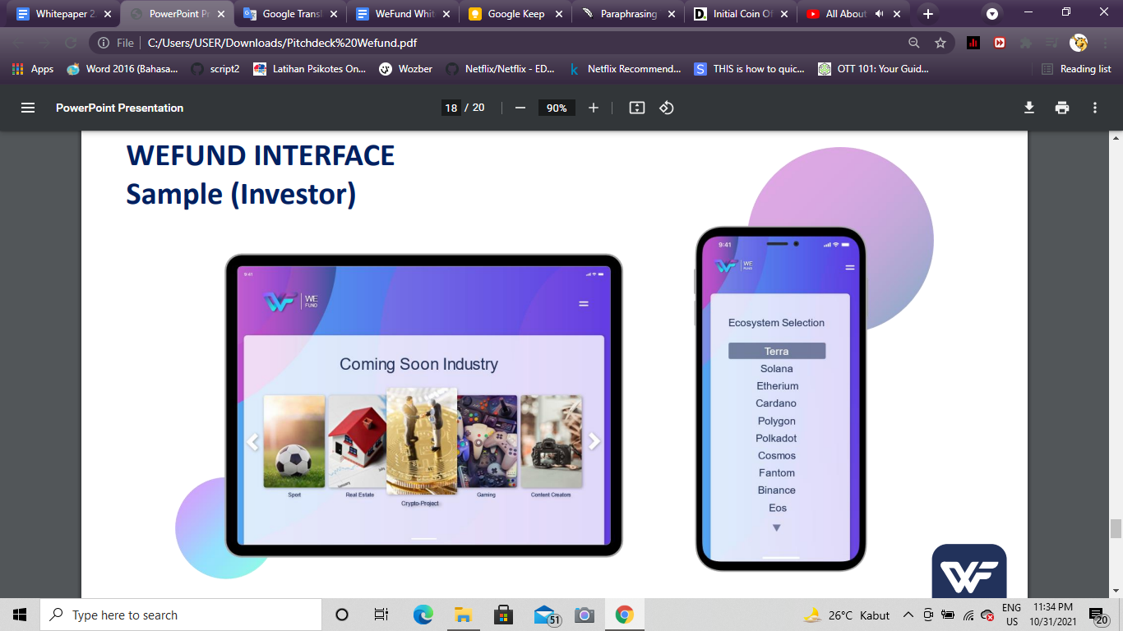

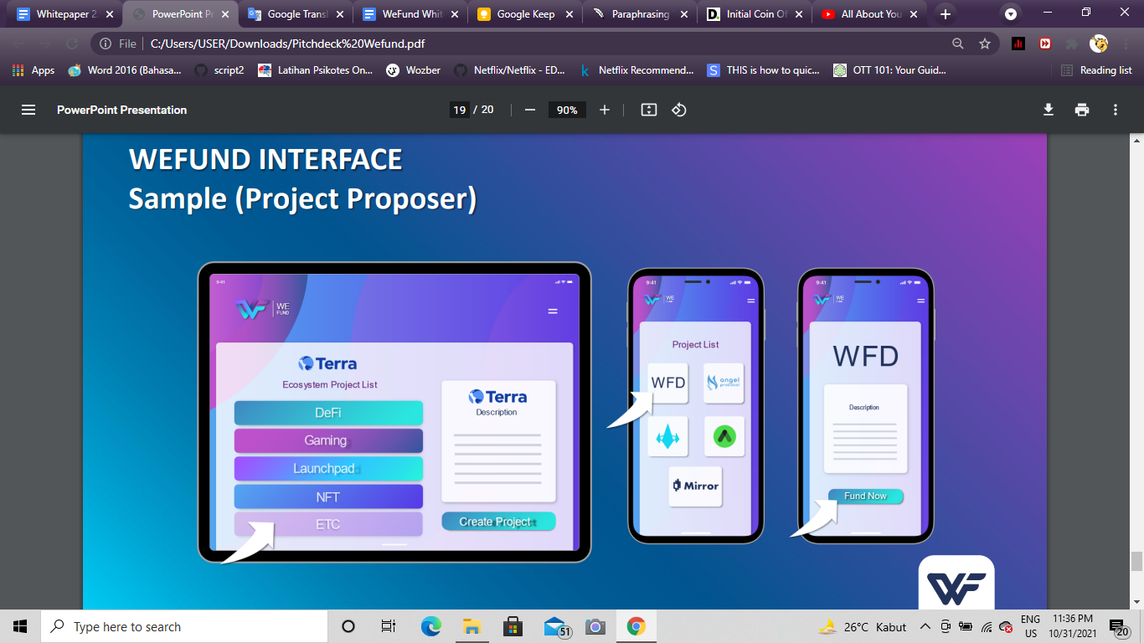

The figure above shows interfaces for backers and project proposers. The investor screen shows a homepage of several upcoming industries to choose from and the preferred ecosystem that backers want to use (Terra, Solana, Ethereum, etc.). Meanwhile the proposers screen shows an ecosystem project list like DeFi, Gaming, etc. is where backers could find a list of projects, including WFD. During the trial period, WeFund is planning to set a transaction fee of 5%. This is for auto financing the project to help the company establish a solid finance foundation.

In the future, WeFund will expand its platform integration of the web app platform and the functionality of the project’s validity process to improve the project proposer’s experience. Currently, each project is manually reviewed by a team of advisors to verify each project that will be listed on the platform, however, a machine learning process is under development that will make this process automatic and efficient.

# Competitive Advantages

These are several competitive advantages that WeFund can guarantee in realization of the platform and the benefits of being a WeFund backer.

1. **Yield Benefit for Backers:**

One of the advantages is project creators can also fund more of their projects via the means of NFTs and exclusive content throughout Mirror protocol, in which backers can receive and trade to increase their investment’s worth.

1. **Governance Voting Power**

WeFund is a crowdfunding and decentralized platform, each person has the right to vote. As for creative projects, there could be restrictions regarding the project’s content (age, country, etc), however, by using WeFund backers of projects could reduce these restrictions by deciding copyrights, royalties, profit sharing, etc with WeFund’s token.

1. **Secure & Refundable Deposits**

The user won't lose the money invested because even if there is a failed project, or project failed due to other reasons, the user can either withdraw the funds or agree on a delay.

1. **Deflationary Token Value**

A deflationary token model is when tokens are gradually phased out of the market. Tokens can be taken off the market in a variety of ways, including token buybacks and token burns by the token creators. The fundamental advantage of such models is that they prevent the market from becoming flooded with extra tokens when more are mined, generated, or sold by the founders.

1. **Low-risk Investment**

Backers can withdraw their funding, eliminating the risk associated with investment into projects on WeFund’s platform that are not performing to the backer’s standards.

1. **NFT Mirroring of Real-World Assets**

By integrating with Mirror protocol, which will reflect between real-world assets and crypto assets, we believe that NFTs are the future when connecting the real world and blockchain. By bringing the stock market or real estate to the form of an NFT, anyone could own these assets and the price will be accurately reflected with the Mirror Protocol.

# Industries Inside WeFund’s Platform 2021-2022:

The purpose of ​​this project is to facilitate fundraising for projects of all kinds and to make the management of funds safe, secure, and guaranteed in case of failure. Additionally, limit legal expenses for the realization of projects by managing everything through smart contracts.

Our project is not just the collection of funds to carry out incredible projects but to create a direct connection between supply and demand, creating the possibility for those interested to be investors in these incredible projects featured on the platform. We can all be investors.

# Use Case Example

There are many useful crypto projects that exist, but financing is one of the obstacles for projects to gain traction. Using WeFund, those projects can receive funding and WeFund will host the fundraising of these projects on its platform. WeFund centralizes project founders and investors on a single platform. In addition, individual investors can be involved in the projects. Our vision is to consolidate project fundraising and to grow the community together with WeFund.

# Upcoming Industries:

WeFund plans to broaden the scope of industries available on the platform, such as gaming, sports, creative, and real estate industries.

## Sport Example

A recent example in the world of sports, the owner of the Barcelona Football Club was forced to sell the best player in the world, Lionel Messi, as his salary was not sustainable. FC Barcelona has 227.3 million fans globally and the fans are willing to spend a lot of money on their team and its memorabilia. A fundraising campaign on WeFund could repurpose the souvignier spending of its fans and instead generate the funds needed to fulfill the salary requirements of Lionel Messi. In this case, a small donation from a small percentage of the club’s fanbase could have fulfilled the funding requirements.

## Game Example

The global video game industry is one of the largest and most stable, and experienced tremendous growth over the past two years. The substantial growth also brought a lot of innovation expected to continually drive the growth in the coming years. One of the key drivers for success of a company or game is the dialogue between game developers and the players. With WeFund, the players can be investors in the projects game developers want to build. With WeFund’s system and profit-sharing incentive, the players will determine the success of projects and any campaigns that do not reach its fundraising goal will have the capital returned to the investors.

## Real Estate example

Real estate is one of the most stable and low risk long-term investments, however, there are many barriers that make real estate investing unattainable. With WeFund these barriers will no longer be a problem as each person invests as much as they want and is able to decide the risk they are comfortable with.

WeFund aims to drastically improve the selection and quality of real estate projects by the direct participation in the investment by all stakeholders. The projects will reach the fundraising goals when a large number of backers are directly invested and involved.

One of the components restricting the growth of real estate, and many other industries, are the inability to reach a larger community of investors that know consumer demands. WeFund brings together the strength of many, not a few, to benefit financially and show support for projects that meet the consumer’s demands.

## Content Creators

Content creators are dependent on the platforms hosting them. For example, in 2021 OnlyFans creators specializing in adult content were (briefly) banned from the platform. According to Time.com, WeFund made the decision to ban adult content because banks and other financial institutions were not willing to invest in OnlyFans when they were hosting adult content creators. With WeFund’s decentralization, there is a solution for content creators to express and share their content without the uncertainty of their content being restricted.

According to insider.com, there were 31 Netflix series that were canceled in 2021 with budget being one of the main reasons. By using WeFund, film makers, producers, and fans can provide the freedom to crowdfund the necessary capital for their projects. With this opportunity, this removes the barrier of budget as the fans are the main driver’s of a project’s success.

# How the Project Works (Interface)

Picture 1.6 WeFund Revenue Model

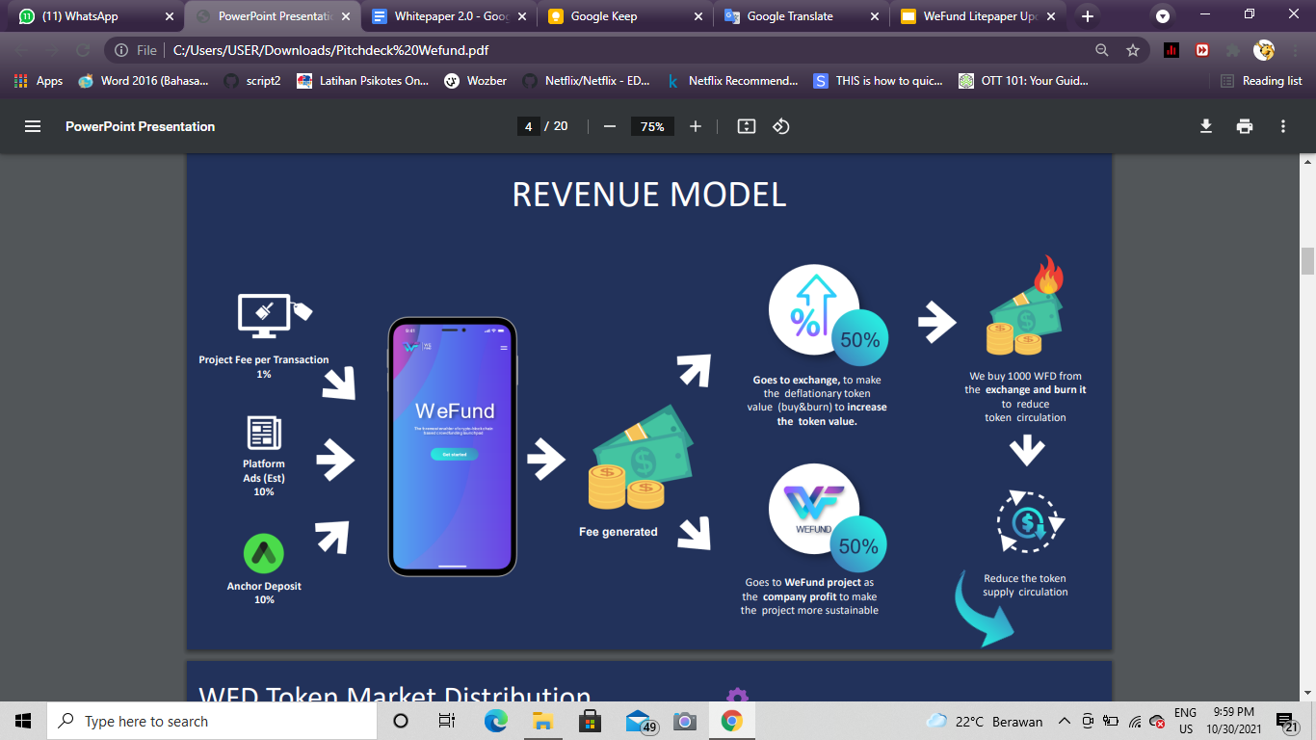

Picture 1.7 WeFund Token Market Distribution

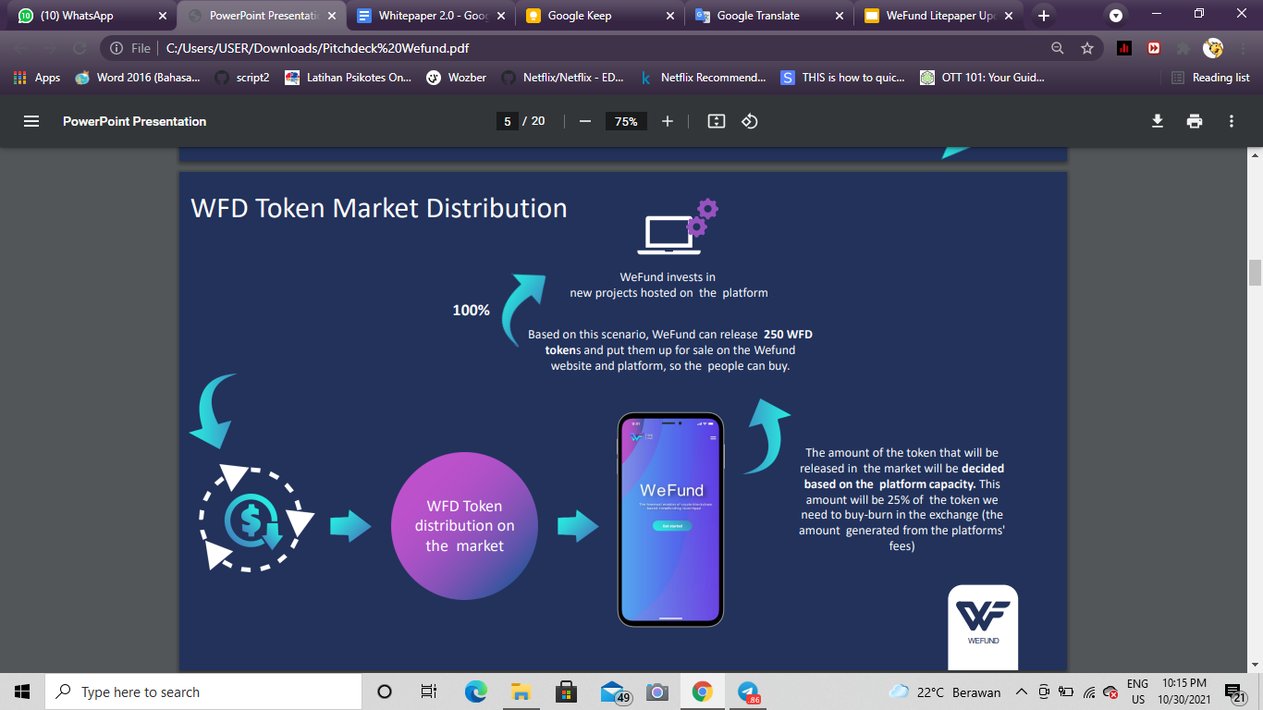

Project creators can list their projects on WeFund by means of the WeFund platform. Anyone is able to list their projects and request any amount they want to raise for the project. A smart contract would register the project and backers can start to back the project. Using the governance token, backers have a voice to help guide each project. The figure above shows the revenue stream of WeFund including the integration of its processes. On the platform, there will be a 1% transaction fee for all projects, a fee for strategic project placement on the platform, and a 10% fee for the deposit of UST to the Anchor Protocol. The anchor deposit will serve as a savings product. The fees generated from the platform are divided into half. 50% is exchanged to make the deflationary token value (buy and burn), increasing the value of the token. The other 50% goes to the WeFund project as company revenue in order to make the project sustainable. In the buy & burn scheme, WeFund would (theoretically) buy 1,000 WFD from the exchange and burn it to reduce the token supply in circulation. From this stage, WeFund starts the token distribution on the market where the amount of the token that will be released in the market will be decided based on the platform capacity. Eventually, WeFund can release 250 WFD tokens and put them up for sale on the WeFund digital platform and 100% of the profit generated will be used as funds for investment in new projects hosted on the platform.

Backers would invest in the project by converting their USD to UST, using Anchor for yield generation. WeFund validates the backers and their backing by WeFund tokens. The 1% fee of the project from the money collected in UST will be used to buy WeFund Token and burn it (deflationary token value). For example, project X with a $1,000,000 fund will have a 1% transaction fee, $10,000. The $10,000 will be used to buy and burn the token value.

WeFund will not filter in the projects that go into the platform, however, on some occasions, we would designate “Project of Interest” as our editor's choice for projects that we are passionate about, deems interesting, or would benefit charities. Backers would be assured their funds are in good hands. A lockup period would be instituted and then backers can get their funds back. Flexibility is also something WeFund has in mind, as project creators would have peace of mind that they can have an agreement to delay the backer, tweak funds required to launch the project, and see previews via the secure secret network.

Project creators can also fund more of their projects via the means of NFTs and exclusive content, in which backers can receive and trade to increase the investment’s worth. As WeFund exists on defi networks, and is decentralized, eliminating the concern and risk of deployment and regulations. The projects would be able to exist without external controlling factors with tokens operating as governance voting rights.

# Tokenomics

WeFund is innovating the way we will launch our platform before we become the launchpad for others. In an effort to fund and fuel the project in its initial stages, WeFund would require baseline resources and foundation in order to develop and function according to the following roadmap. Please see below for our token distribution layout.

Picture 1.8 Tokenomics Allocation

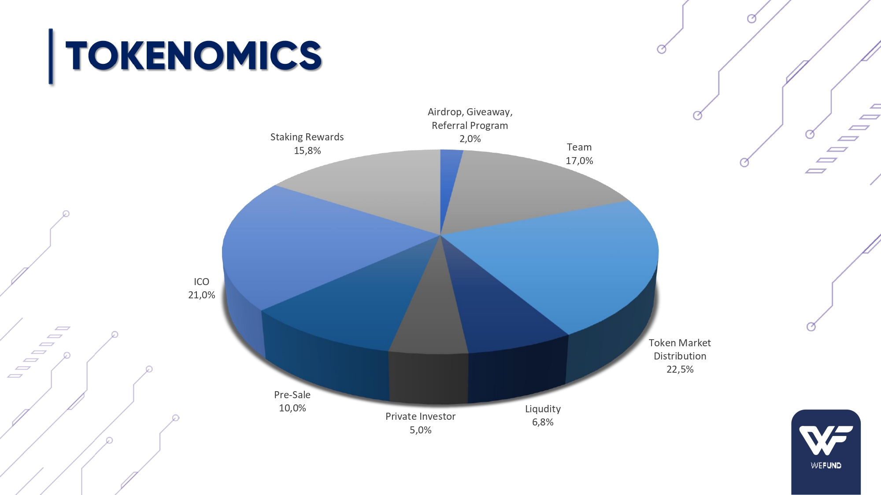

The total supply of WFD token will be 100,000,000. WeFund would distribute 17% of the total allocation to the WeFund team to sustain and grow the workforce supporting WeFund’s development and operation. Another 2% of the token supply will go to Airdrop, a referral program and giveaway for marketing and expansion. 22.5% will go to market distribution to simulate a “buy and burn'' system to limit the token’s supply and demand volatility. To prevent liquidity instability, 6.8% of the token will be allocated for all marketable assets. A total of 36% allocation will be distributed to private, pre-sale, and ICO investors. To promote token staking, 15.8% of allocation will be designated for staking rewards, locking up cryptocurrency holding in exchange for rewards. To maintain market stability, the token will be frozen before the launch, subject to 20% yield staking and the team token will be frozen for 24 months.

WeFund is looking to raise $300,000 USD during the private sale period in exchange for 5%, or 5,000,000, tokens at a price of $0.06 USD. The purpose of the private sale is to support WeFund’s product launch and back-end development. After projects on the platform, revenue generated, and technical milestones are met, WeFund is looking to raise $5,000,000 USD equal to 10%, or 10,000,000, tokens at a price of $0.50 USD,. Finally, the ICO will raise $29,700,000 and will distribute 21%, or 21,000,000, tokens at a price of $1.41 USD.

# Token Value

Table 1.2 WeFund Token Value

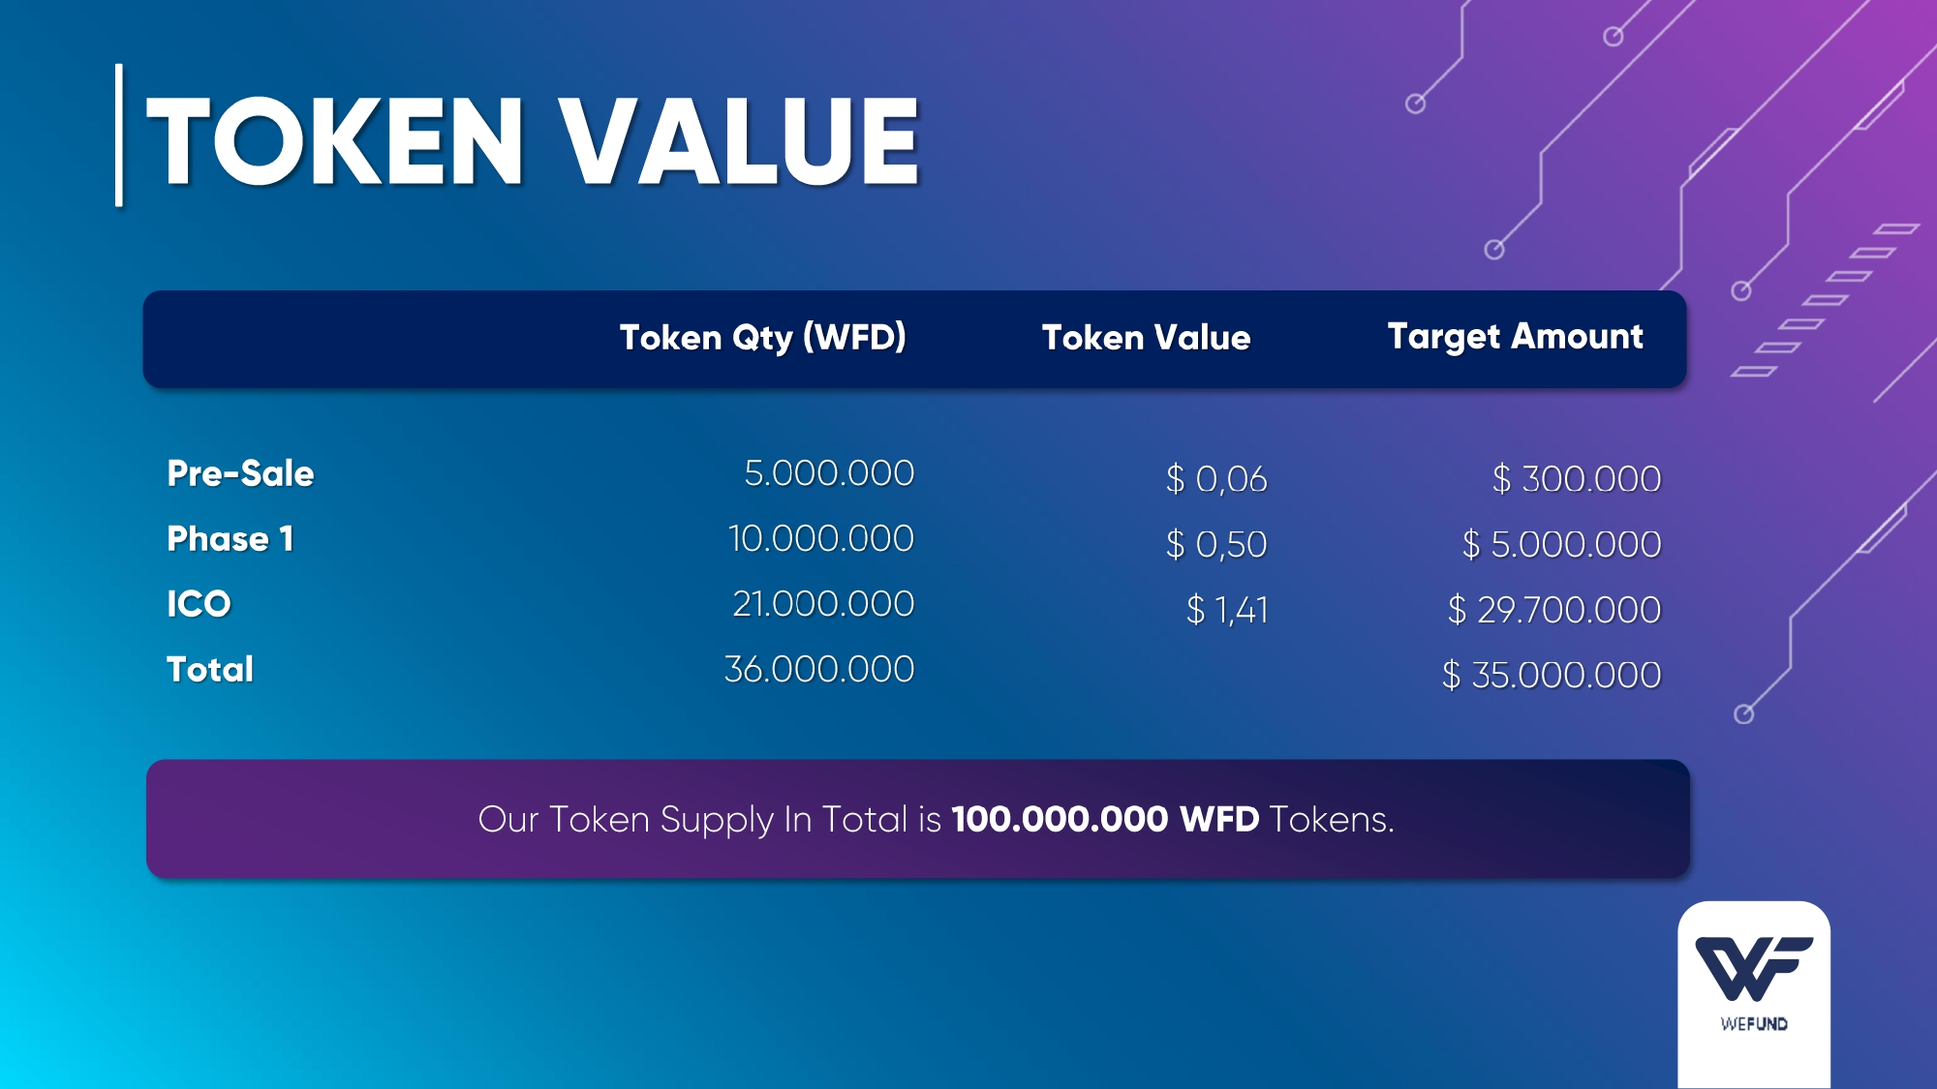

# Profit Sharing Distribution

WeFund’s profit distribution is designed to ensure sustainable usage of WeFund’s cashflow. WeFund plans to use 25% of revenue to maintain the organization, 2% dedicated to WeFund’s crypto experts, 3% of revenue will be dedicated to profit sharing to private-sale investors, 10% of revenue reinvested to projects on the WeFund platform, and 60% of revenue used by WeFund’s core team expenses. The 3% of revenue for private-sale investors will be equally distributed by the amount each investor invested.

Picture 1.9 Profit Distribution

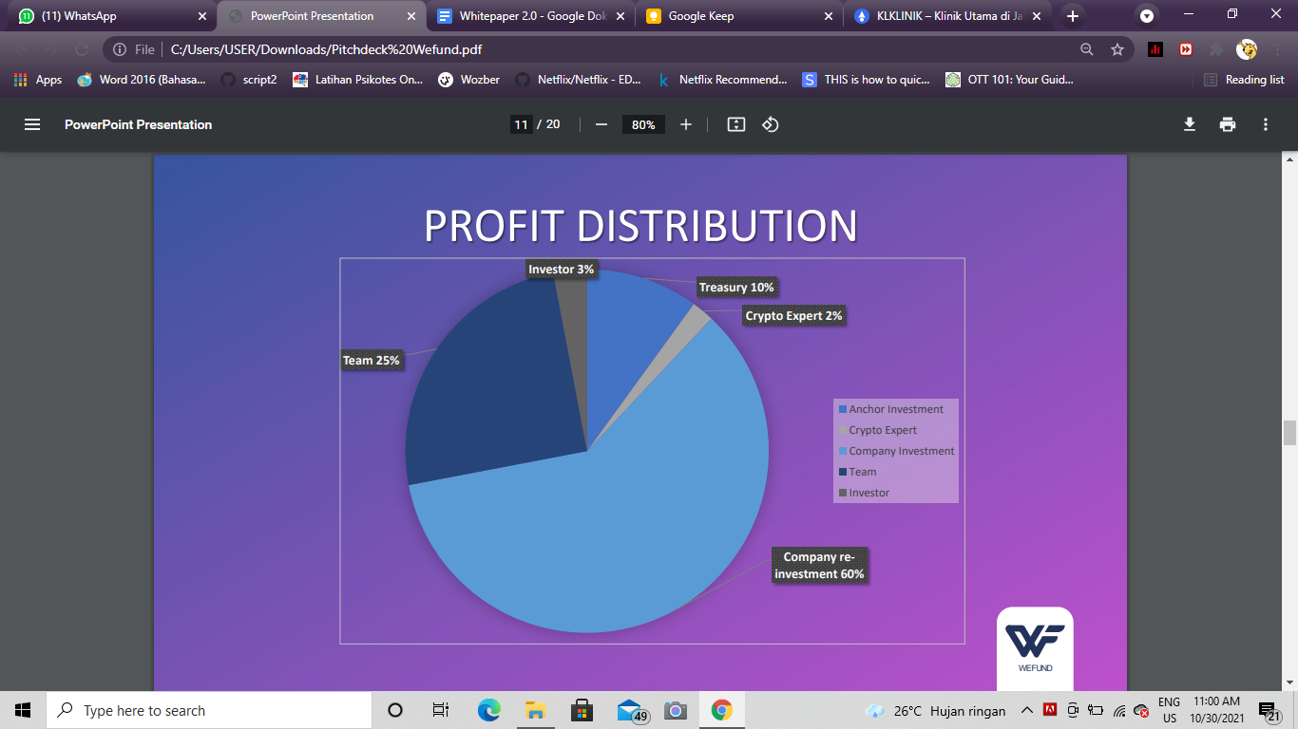

# Token Vest Period

Vesting is the practice of releasing tokens that have been held for a fixed amount of time. Smart contracts effectively lock funds set aside for this purpose for a specified length of time, thereby blocking access to the tokens until pre-set conditions are met. For example, the team can set aside 5% of coins to be released once a month, quarter, or year throughout the project's development.

Picture 1.10 Private Investor Vesting Period

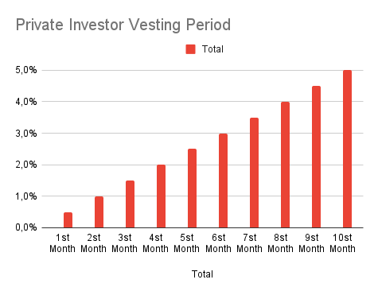

The graph above shows vesting schedules for private investors. 0.5% of the vested tokens are released within the 1st month, and 1% in the 2nd month, and the amount goes up until the 10th month where the complete 5% of vested tokens are released. This structure is advantageous because if a single, or few, entities owned 20% of all tokens produced from the start of the token production event, they could easily cause supply swings that would be harmful to the token ecosystem and its price. This could pose significant risk to the token's stability.

Picture 1.11 Pre-sale and Team Vesting Period

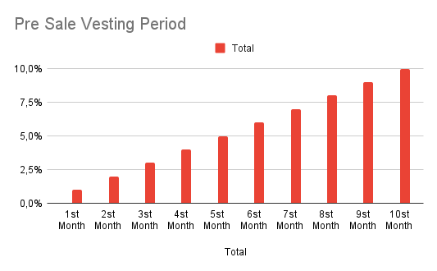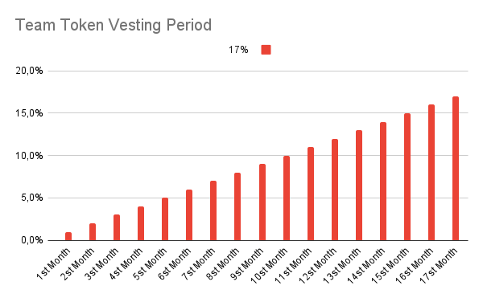

The pre-sale and team token distribution are comparable to the investor distribution, only difference being the amount of token vested each period. For presale tokens, 10% of the entire token distributed will be vested over the course of 10 months. For team tokens, 17% of the entire token distributed will be vested over the course of 17 months. The private investor vesting schedule will start one the ICO along with presale tokens and ICO tokens. Team token vesting will begin once the investor vesting has been completed.

# Token Utility

1. **Ads Payment**

WFD token can be used to pay for ads within the platform, allowing projects to be displayed exclusively for the potential backers to see and review.

1. **One percent (1%) Transaction Fee**

WeFund will implement a 1% transaction fee for projects listed on WeFund. This is done with the purpose of purchasing our token so WeFund are able to fund various projects on the platform.

1. **Increasing Token Value**

By purchasing WeFund token, the token will naturally increase in value.. To increase the value of the tokens, it must generate greater demand than the current supply. WeFund determines that the most strategic course of action is to purchase and destroy existing tokens over time. Smart contracts are used to achieve this goal. As a result, the number of tokens available is limited resulting in increased value. This can be done once to stabilize or enhance the token's value, or it can be done on a regular basis.

# Anti-Scam Measures:

​​The integration with Covalent will bring more transparency and anti-scam measures to token sales facilitated on the WeFund platform. [Covalent](https://www.covalenthq.com) brings rich data from the blockchain to inform investors about tokens, token projects, transactions, and historical data of crypto-assets and wallets. Token sale projects using these tools will be able to see if wallets have been used for illegal purposes such as money laundering and other suspicious activities. Additionally, token sale projects can link the team’s identifying data to their token sale pools to boost trust and transparency to potential buyers.

Covalent’s ability to provide granular, historical per wallet data will allow token sale and swap participants to know who they are interacting with. This type of transparency will build trust in the network and create a safe environment for traders and investors of all kinds.

Covalent’s technology will allow WeFund token pool creators and participants to check the legitimacy of token contracts using a wide variety of heuristics and analytics:

* Token contract age
* Proxy patterns (red flag for potential rug pulls)
* Blacklists, Scams and other warning flags
* Curated token lists
* Token contract verification
* Token holders
* Top wallets
* Transaction volume in the last day, week, month, year

All of this data will be available through Covalent’s tools to allow for token pool creators and participants to choose to use in order to augment trust and transparency in sales and swaps.

# Technical Roadmap WeFund

Picture 1.12 Road Map 2021-2022

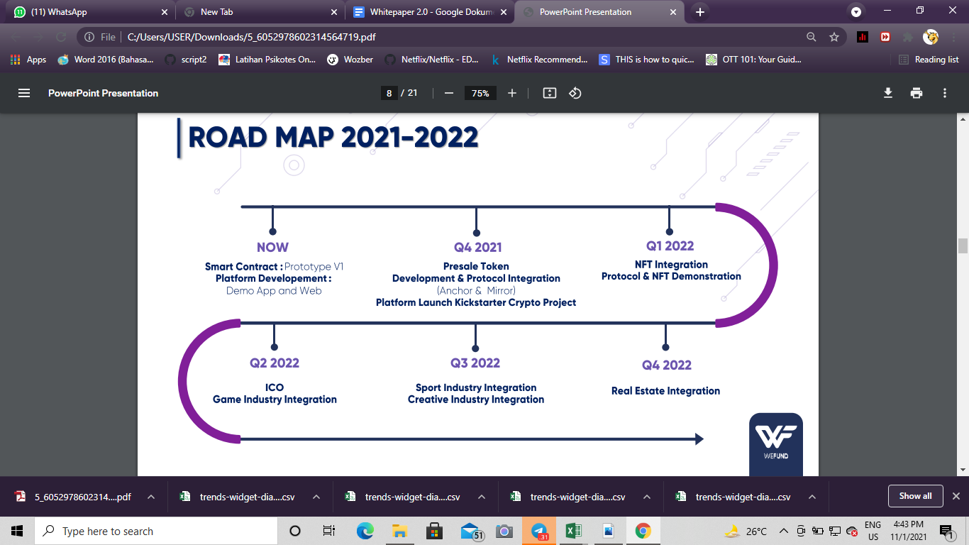

# Platform Integration

* **Anchor**



* **Mirror** 

# TEAM

## Founders



**El Guapo:** He is the person behind the development of Fan$quad smart-contract that was deployed on Col-4 during the Hackathon organized by Terraformlab.He has a wealth of experience in coding, with a deep understanding of C, C++, Javascript, VBA, Java, Python, Rust languages (to name a few). In 2018 he moved his focus into Solidity, PHP, & HTML 5, to follow his vision of creating advanced web3.0 applications integrated with the blockchain. His role is to ensure delivery of the Smart Contracts, Web App, and technical infrastructure yet also for the business side. From the business side, he had several businesses before such as a hotel & restaurant (Ristorante-Bar Lanca), a smart-home startup, and the last one was mosquito solution start-up. Most of the businesses successfully had an ROI within less than 1 year.



**La Leona:**  A dynamic individual, who worked at Tencent as an operation specialist, in a partnership division. Before Tencent, she was senior partnership manager at Bigo. She previously held a senior account executive position at one of the digital marketing agencies under Jet Group and was a manager at Waves who successfully helped founders to raise $1.2M in pre-seed funding, before turning her attention to crypto. She is one of the founding partners and driving forces behind the concept of WeFund. She was the core team behind the hackathon project of Fan$quad together with the other ex co-founder.

## Advisors



**Jason:** as the business advisor. He is aworld explorer, entrepreneur, and blockchain technology enthusiast. Came from a career in Silicon Valley building web applications during the dot-com boom. Wanting to do it all over again, this time helping to build Web 3.0.



**The Oracle:** as the crypto-startup industry advisor/validator, he comes from a background in investment and corporate finance. After completing his education he worked as a Business Analyst for a large tech company in Seattle, Washington USA building AI applications to identify high-risk sale transactions. He now is an investment manager for a prestigious silicon valley venture capital firm located in Jakarta, Indonesia managing investment deals in the Southeast Asia region.

**Laurent:** as the Real-estate advisor/validator. He is an experienced Business Project Manager with a demonstrated history of working in the pharmaceuticals industry. Skilled in Business Development, Project Management, Business Planning, Analytical Skills and Market Research. Strong finance professional with a dual master degree Master focused in International and Corporate Finance. Currently holding a real estate company as Founder & President of Mio&partners.

## Other Team



**Naya Fika:** as a front-end developer, he currently holds a role as a developer that focuses on translating designs and coupling them into functional modules with the back end. Building web apps and ensuring UX functionality flows nicely from the back-end to the user side. Main technical expertise as Solution Architect, Data Engineer, and Front End Developer. Works at leading Professional Service Network as Consultant. Wrote and published papers as a college student.



**Jiya:** as a graphic designer, she is an artist who had a strong background in multimedia, starting her career as Youtube and successfully generating 1M+ views on her YouTube channel. Passion and creativity are what drive her career path and she worked as a graphic designer in one of the biggest NGOs in Indonesia.

**Cosmic Cat:** as a data analyst,she is a data enthusiast who resided in Jakarta and currently working for the biggest multimedia company in Indonesia namely MNC Media as a data analyst. Her interest in data has proven since her study in university when she took part as a big data lab assistant as well as being involved in social computing and big data association.

# **References**

Barnes, R. (2021, June 9). *Cryptocurrency liquidity - how to find the best liquidity provider?* B2Broker. Retrieved November 1, 2021, from https://b2broker.com/news/cryptocurrency-liquidity-and-finding-the-best-liquidity-provider/.

​​Barry, E. (2021, August 26). *Why did onlyfans reverse its ban on sexual content?* Time. Retrieved October 8, 2021, from <https://time.com/6092947/onlyfans-sexual-content-ban/>.

Becker, S. (2021, October 23). *What is crypto staking?* SoFi. Retrieved November 1, 2021, from https://www.sofi.com/learn/content/crypto-staking/.

Best, R. de. (2021, October 11). *Number of crypto coins 2013-2021*. Statista. Retrieved October 30, 2021, from https://www.statista.com/statistics/863917/number-crypto-coins-tokens/.

Crypto Dictionary. (2021, February 28). *Crypto dictionary - vesting*. Crypto Dictionary - Vesting meaning and definition. Retrieved November 1, 2021, from https://cryptodictionary.netlify.app/what-is-vesting/.

DreamTeam.gg. (2018, September 3). *Token Vesting Process - why is this a great idea?* Hacker Noon. Retrieved November 1, 2021, from https://hackernoon.com/token-vesting-process-why-is-this-a-great-idea-34933e9e8bc5.

Glier, G. C. (2018, November 8). *Factors that affect the value of Token*. Medium. Retrieved November 1, 2021, from https://medium.com/blocktoken/factors-that-affect-the-value-of-token-c489ecab2a1d.

*Global film and video market REPORT (2020 to 2030) - COVID-19 impact and recovery - ResearchAndMarkets.com*. Business Wire. (2020, August 21). Retrieved September 30, 2021,from https://www.businesswire.com/news/home/20200821005370/en/Global-Film-and-Video-Market-Report-2020-to-2030---COVID-19-Impact-and-Recovery---ResearchAndMarkets.com.

*Largest video game companies by market cap*. CompaniesMarketCap.com - companies ranked by market capitalization. (n.d.). Retrieved September 30, 2021, from https://companiesmarketcap.com/video-games/largest-video-game-companies-by-market-cap/.

Mee, G. (n.d.). *What is a good engagement rate on Twitter?* scrunch. Retrieved October 5, 2021, from https://scrunch.com/blog/what-is-a-good-engagement-rate-on-twitter.

Nahar, Pawan. “Explained: What Is Coin Burning in the Cryptocurrency Universe?” *The Economic Times*, https://economictimes.indiatimes.com/markets/cryptocurrency/explained-what-is-coin-burning-in-the-cryptocurrency-universe/articleshow/85658968.cms.

*New study reports $1.1 trillion global sports market and Predicts 3.5 billion in global Sports participation by 2025*. New Study reports $1.1 Trillion Global Sports Market and Predicts 3.5 Billion in Global Sports Participation by 2025 | SIGNA Sports United. (n.d.). Retrieved September 30, 2021, from https://signa-sportsunited.com/new-study-1-1-trillion-global-sports-market-and-predicts-3-5-billion-in-global-sports-participation-by-2025/#:~:text=Global%20sports%20is%20a%20%241.1,the%20rate%20of%20GDP%20growth.

Published by Statista Research Department, & 10, A. (2021, August 10). *Global music industry revenue 2023*. Statista. Retrieved September 30, 2021, from https://www.statista.com/statistics/259979/global-music-industry-revenue/.

*Real estate market size report 20/21*. MSCI. (n.d.). Retrieved September 30, 2021, from https://www.msci.com/our-solutions/real-estate-investing/2021-market-size-report.

Renfro, K. (2021, March 5). *31 TV shows that are canceled or ending in 2021*. Insider. Retrieved October 8, 2021, from https://www.insider.com/tv-shows-canceled-ending-in-2021.

Reynolds, C. (2020, November 28). *The deflationary token economic model behind current's $CRNC*. Medium. Retrieved November 1, 2021, from https://medium.com/current-crnc/the-deflationary-token-economic-model-behind-currents-crnc-2fc44de221bd.